Installation Manual

Version IM-2-2014-05-28

For

PlasmaGraph

|  |  |  |
| --- | --- | --- |
| Daniel E. Quintin |  | Gerardo A. Navas |
| Computer Science Undergraduate Program |  | Computer Science Undergraduate Program |

Polytechnic University of Puerto Rico

Electrical & Computer Engineering and Computer Science Department

May 28, 2014

Revision History

|  |  |  |  |
| --- | --- | --- | --- |
| **Name** | **Date** | **Reason For Changes** | **Version** |
|  |  |  |  |
|  |  |  |  |
|  |  |  |  |

Table of Contents

1. Introduction 1

1.1 Overview 1

1.2 Audience 1

2. Installing PlasmaGraph 1

2.1 Requirements 1

2.2 Step 1: Install Java 2

2.3 Step 2: Run PlasmaGraph 2

3. References 2

# Introduction

## Overview

PlasmaGraph is a software tool designed for optimizing the process of gathering and analyzing output data produced by the mirror and cusp plasma machine at the PUPR by letting the user generate graphs with this data. In other words, PlasmaGraph uses data files produced by the plasma machine in order to generate graphs that can be saved as images in the user’s personal computer.

This manual will explain all the steps necessary to install PlasmaGraph in any personal computer that supports Java [1].

## Audience

This document is intended for researchers interested in using PlasmaGraph for analyzing data.

# Installing PlasmaGraph

## Requirements

1. 15’’ Monitor with a resolution of 1200x700 and refresh rate of 30Hz
2. A standard alphanumeric American (QWERTY) keyboard
3. One 3.20GHz dual core processor
4. 500Mb of available HDD
5. 512Mb of RAM
6. Internet Connection
7. Internet browser

## Step 1: Install Java

To install Java go to their official website and follow the instructions provided under the option “help resources >> installing Java”. Alternatively, you can go to Java’s installation instructions page using the following URL: <http://www.java.com/en/download/help/download_options.xml>

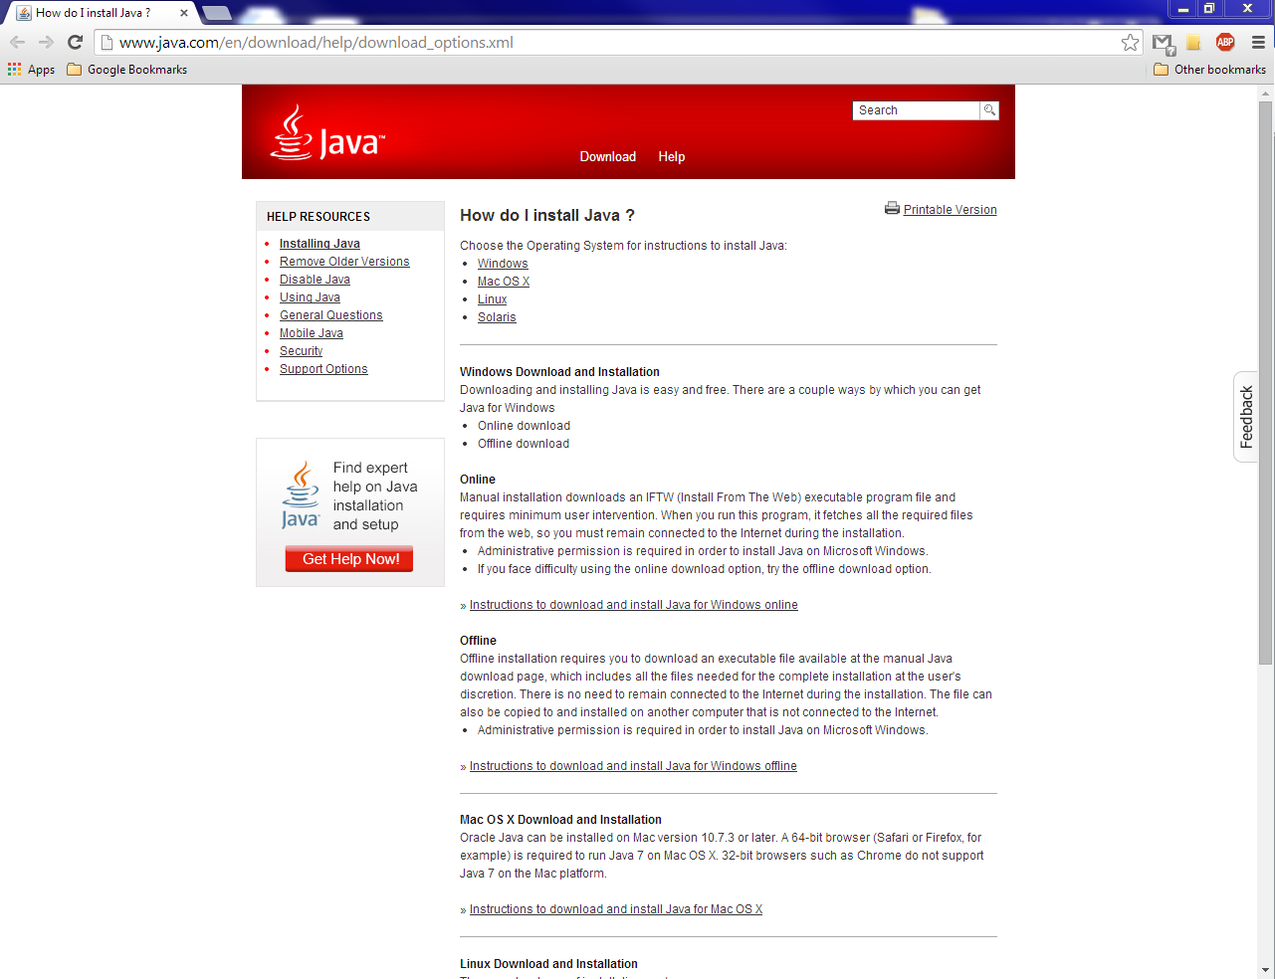

Figure ‑: Java website

## Step 2: Run PlasmaGraph

Double click on PlasmaGraph.

# References

|  |  |
| --- | --- |
| [1] | Oracle Corporation, «Learn About Java Technology,» [En línea]. Available: https://www.java.com/en/about/. [Último acceso: 21 1 2014]. |